Project Report

Global Coffee Trend – Insight for Strategic Expansion

Tarun Peela

U60500002
Table of Contents
- Abstract 3
- Introduction 3
- Research Questions 4
- Design Process 4
- Key Findings 13
- Limitation and Further work 14
- Acknowledgement 15
- References 15

Abstract
If you were the CEO of a coffee chain, which country would you like to open a new store in? Coffee remains a dominant position in the beverage market with the industry experiencing continuous growth. For example, in 2023, the United States coffee market earned nearly $85 billion in revenue, with roasted coffee accounting for the majority at over $70 billion.
This project visualizes overall coffee consumption patterns from 1990 to 2023, including preferable coffee types.
The end user of this project would be CEO and executive of coffee a coffee brand. They would use our visualization to make a strategic decision about expanding their businesses into new markets and understand consumer behavior patterns in coffee consumption. Additionally, they can gain insights into potential markets for importing coffee beans and types.

Introduction

Project Purpose
This project aims to provide data-driven insights to guide the strategic expansion of a coffee chain business into international markets. By visualizing coffee consumption trends across 94 countries from 1990 to 2023, the analysis uncovers patterns in consumer behavior and identifies promising markets for opening new stores. Additionally, I aim to determine which country has the highest coffee consumption rate by considering the per capita consumption rate rather than solely focusing on total consumption figures. This analysis will enable us to identify countries where coffee consumption is particularly high relative to their population size, indicating strong market potential for coffee chain expansion or strategic sourcing of coffee beans.

Project Description
Using Tableau visualizations, we explored global coffee consumption trends and patterns. Our analysis included 13 worksheets and 5 dashboards. Initially, I examined coffee production and consumption from 1990 to 2023. Then, I highlighted the top 5 countries in coffee production, imports, and exports. Shifting focus, I identified the most consumed coffee varieties and the top 5 countries for domestic consumption. Moreover, I analyzed per capita coffee intake using a tree map visualization, capturing potential factors beyond population size in coffee consumption.

Research Questions

- Which countries have shown a consistent increase in coffee consumption over the years?

- Is the increase in coffee consumption due to an increase of population? Or is it a market trend? How can we compare the population to coffee consumers?

- From which countries should we source our coffee beans to maximize profit?

- Are there noticeable trends in consumer preferences for coffee types (e.g., Arabica vs. Robusta) across different countries?

Design Process

1. ​Datasets used : Refer to Section VIII.

I have used Coffee distribution dataset that includes coffee bean production, coffee bean imports and export information by each country, Coffee consumption dataset that provides domestic coffee consumption units and representative coffee type. I also merged population dataset with coffee datasets, aligning with each country.
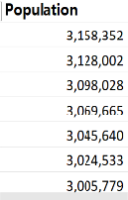
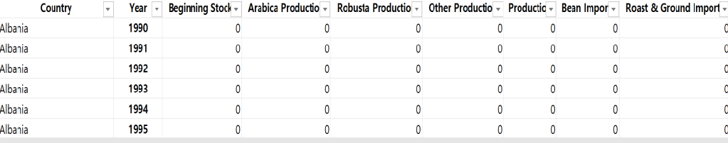....

2. ​Data Cleaning
The data available for us has a structure as shown below with countries and attribute names in the rows and years in the columns.

Data structure was modified to suit our requirements and made a tableau friendly format to readily assess the parameters and attributes for our intended results.
Years in the columns were transposed to rows. Date for each attribute like Production, Consumption, Imports and Exports were placed in rows against each country for different years. Population data was joined to the below data from the population data set.

Design
    - Stage 1: Coffee production, consumption, exports and imports across years
I have created separate line charts with trend line showing the coffee production, domestic consumption, imports and exports between the years 1990 and 2023 by placing years in x-axis and sum of production, consumption, imports and exports in y-axis.
The visuals below show coffee production, domestic consumption, imports and exports respectively.

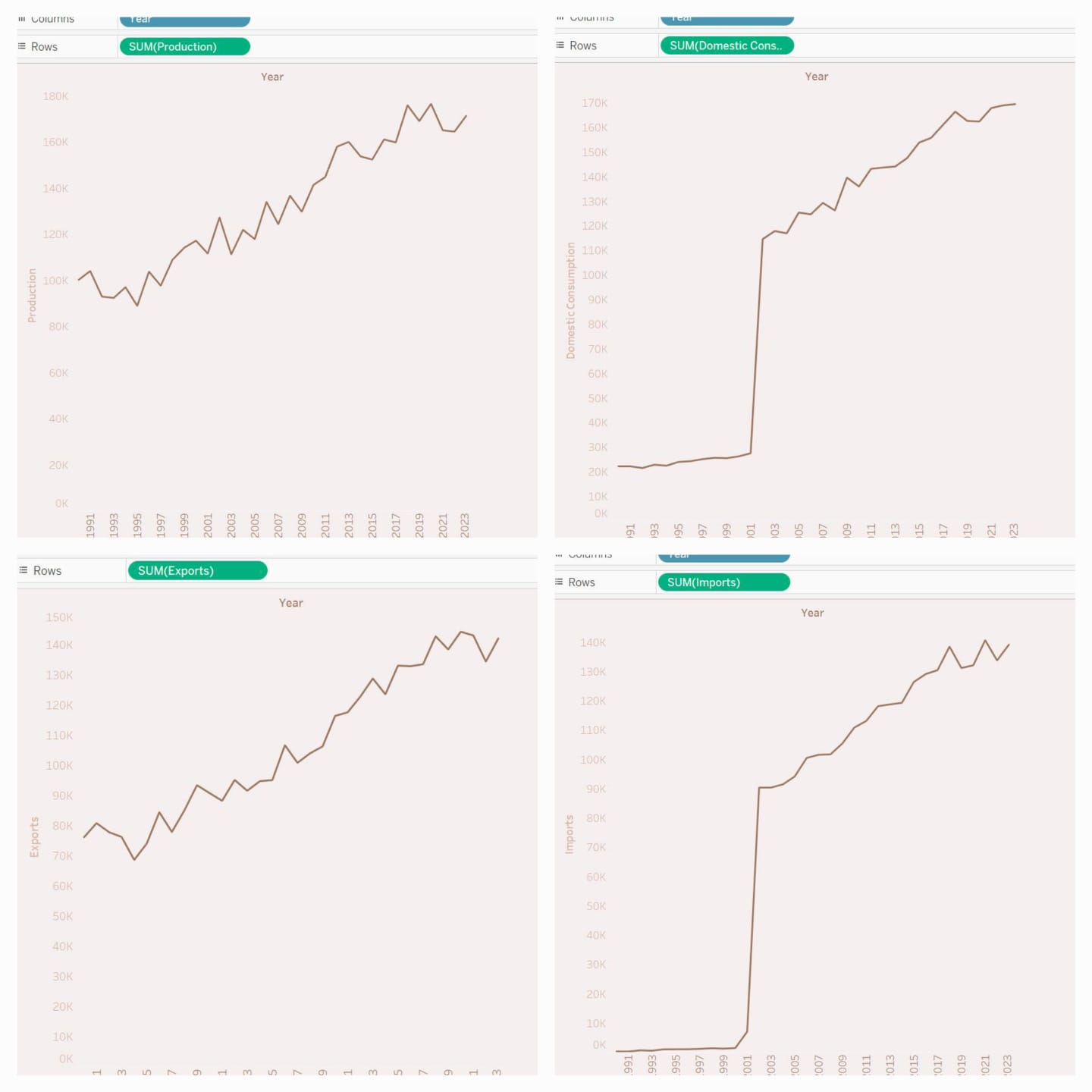
    - Stage 2: Coffee production, Consumption, import and export types:
I created vertical bar charts to compare the coffee production, consumption, import and export types. To show how they are being compared across the years, “Year” was added to the pages. The sum of production, consumption, imports and exports for each type was shown by the length of the bar. Labels were added to show the numbers on the top of the bar.
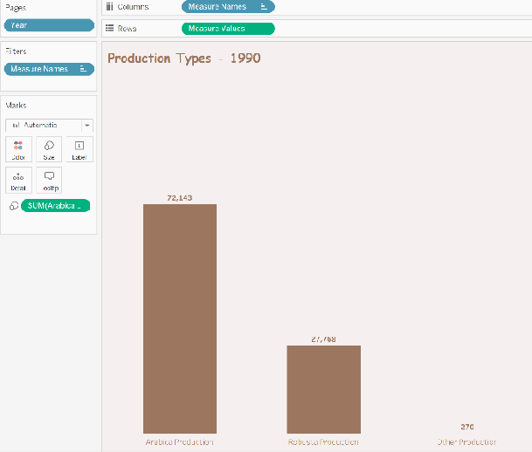
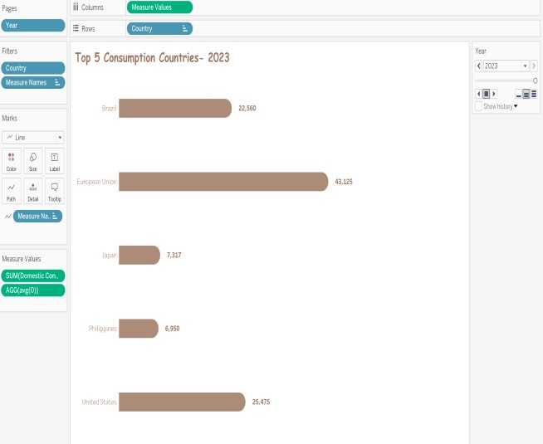
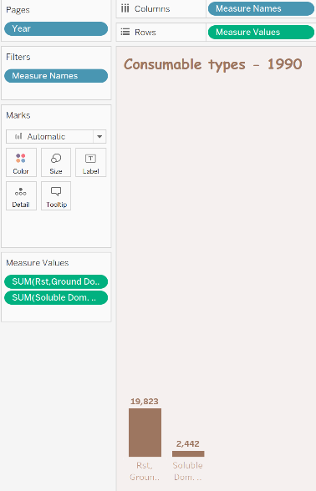
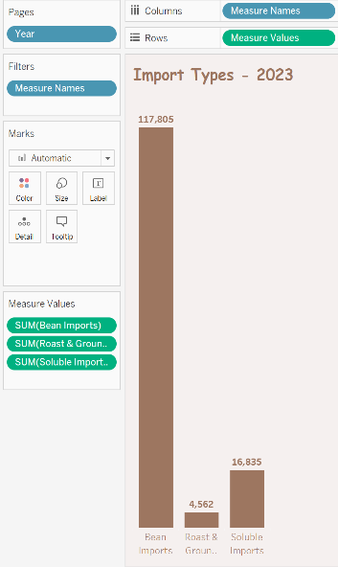
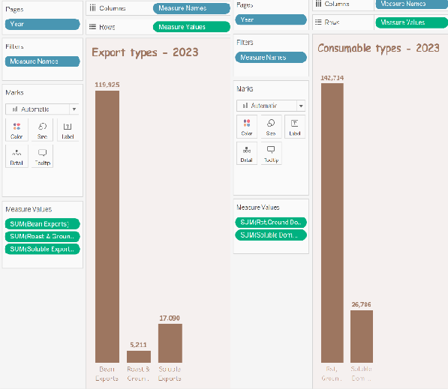

    - Stage 3: Top 5 Coffee producing countries (1990 vs 2023)
I created horizontal bar charts to compare the top 5 countries in terms of production, consumption, import and export. To show how they are being compared across the years, “Year” was added to the pages. The sum of production, consumption, imports and exports for each type was shown by the length of the bar. Labels were added to show the numbers on the top of the bar.

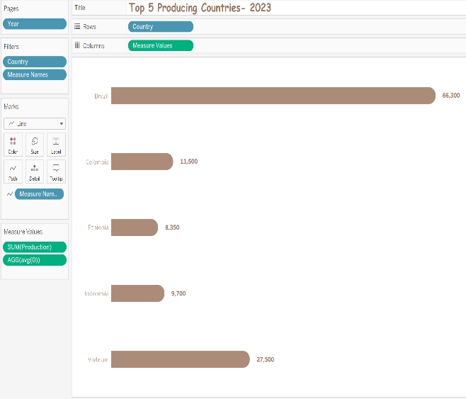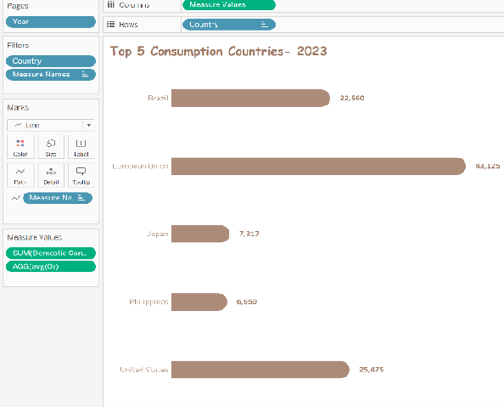
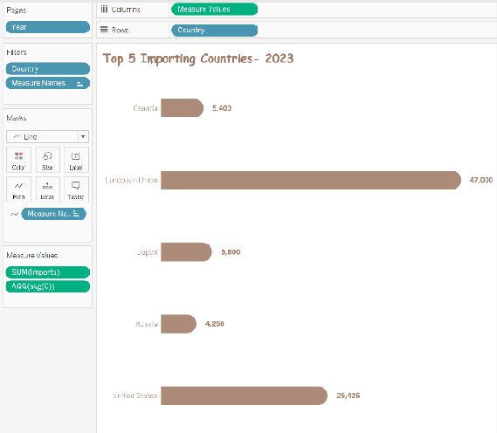
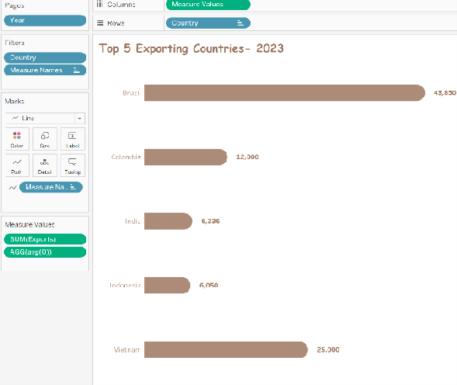
    - Stage 4: Map view of coffee consumption across the country
A map view to show the consumption of coffee across the countries was created and the map background was changed from light to normal. Country was placed on the details and a new coffee bean png file was downloaded and copied into shapes folder in My tableau repository which was used in the map instead of the regular circles.

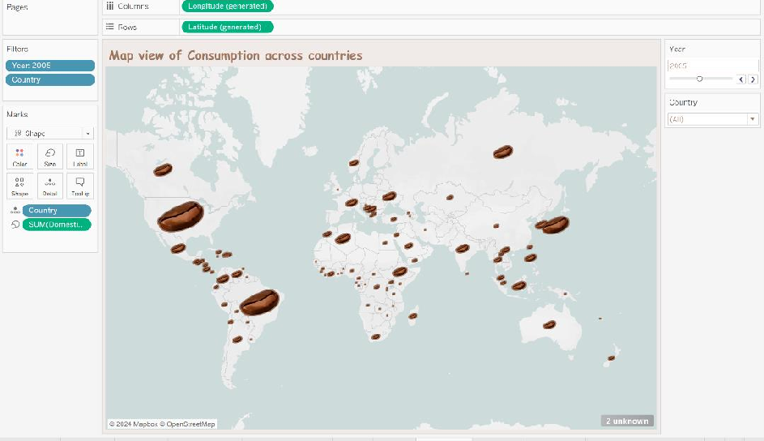
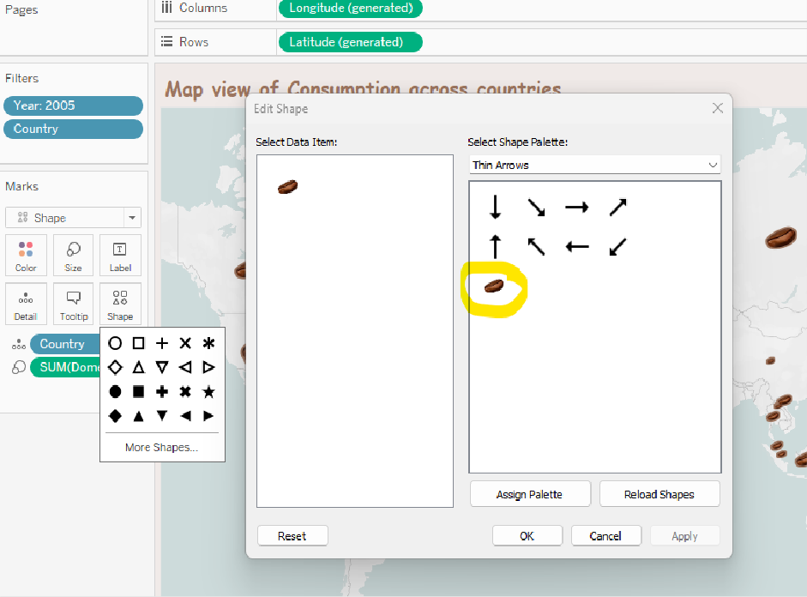

    - Stage 5: Tree map of relative coffee consumption per capita
To make a visual that helps quickly identify the top countries with highest ‘Consumption wrt Population’, a tree map was created using the calculated field and countries with Year and country as filters. The colors were changed to suit our theme.

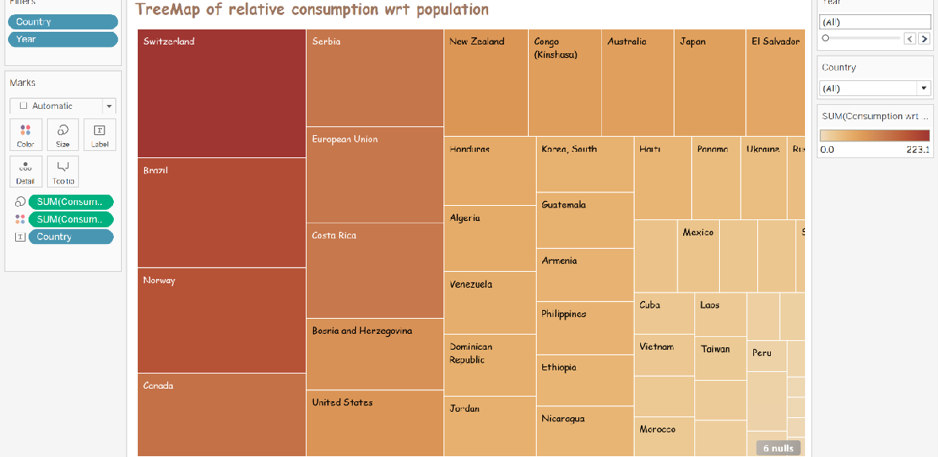

    - Chapter 1: The overall coffee trends

In this chapter, we provide an overview of coffee trends, analyzing various aspects such as production, consumption, imports, and exports across the country. We observed significant growth in coffee production, which surged by 71% in 2023 compared to 1990. Additionally, domestic coffee consumption experienced a remarkable increase, growing approximately 6 times more compared to 1990. Moreover, the data indicates a substantial rise in coffee imports, which increased by 400 times compared to 1990, reflecting an increasing demand for coffee products. Coffee exports also showed a noteworthy growth, with an 87% increase from 1990 to 2023.

    - Chapter 2: Coffee production and consumption across the year (ex. 2023)
In this analysis, I delve into the dynamics of coffee production and consumption over the years. My findings reveal that Arabica consistently surpasses Robusta in production across almost all years, with Brazil emerging as the leading producer. The sudden increase in 2002 was due to the Euro notes and coins launched in 12 EU countries, aggregating the consumption of the EU countries. I will be talking further about this limitation in Section VI.
Additionally, My analysis highlights that Roast & Grounded coffee type emerges as the most consumed variety. This preference can be attributed to the increasing adoption of domestic coffee machines and evolving consumer preferences, characterized by a shift towards specialty blends.

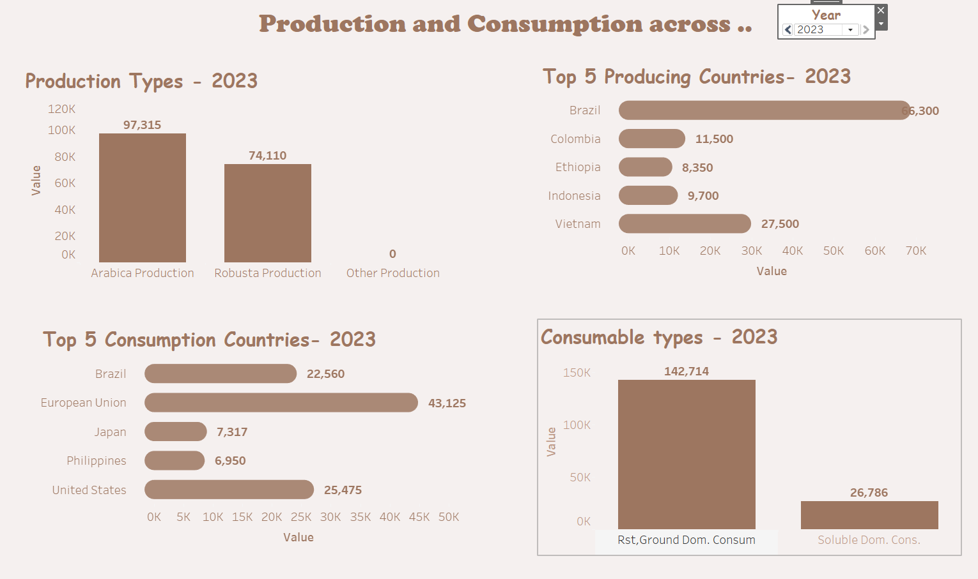

    - Chapter 3: Coffee imports and exports across the year (ex. 2023)
my analysis in this chapter reveals a correlation between coffee export volumes and production levels, with Brazil standing out as the largest exporter of coffee globally. Notably, the majority of coffee exports consist of whole beans, indicating a preference for unprocessed coffee products in international trade. It's worth noting that Vietnam was the second-largest coffee exporter globally, further highlighting the importance of Southeast Asia in the coffee export market.

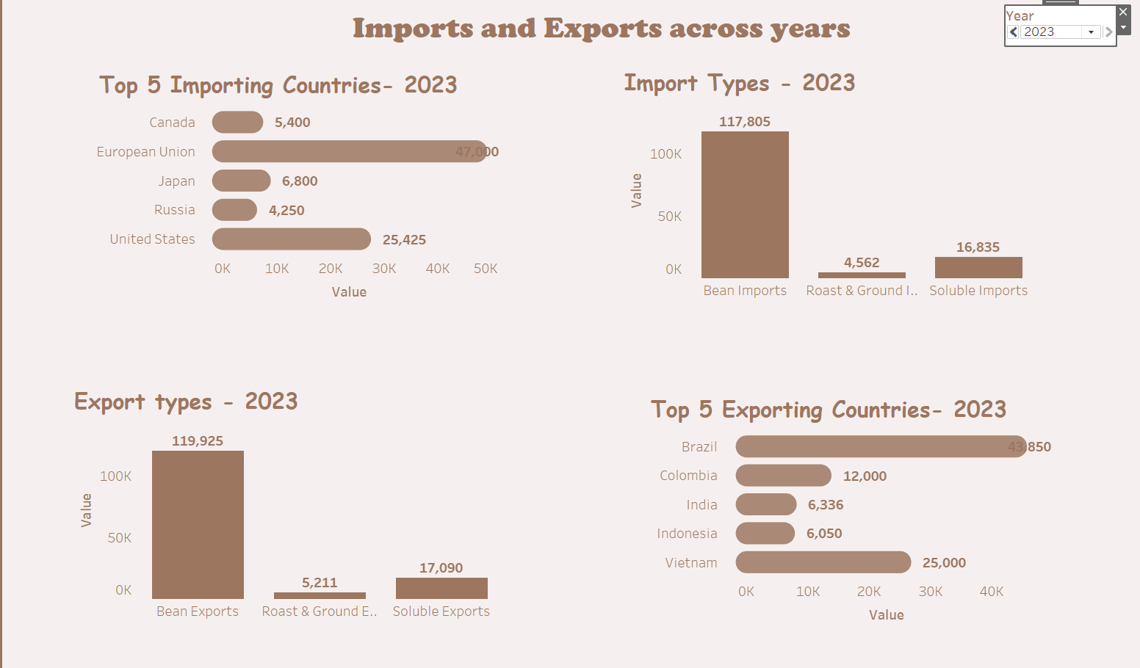

    - Chapter 4: Coffee consumption trends throughout the year in different countries
This chapter offers a comprehensive visualization of coffee consumption across different countries, providing a clear overview of global consumption trends. The European Union emerges as the region with the highest coffee consumption numbers, indicating a strong coffee culture and widespread consumption habits among European consumers. Following closely behind are the United States and Brazil, as mentioned earlier as significant contributor in the global coffee market.

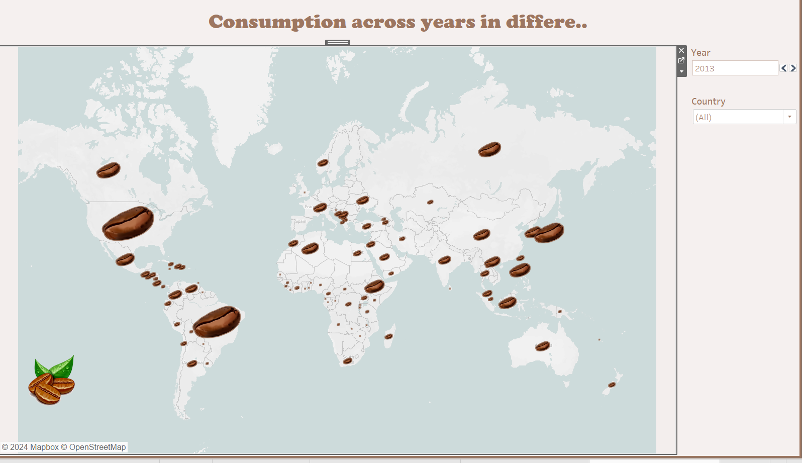

    - Chapter 5: Per capita coffee consumption
This chapter highlights the importance of looking at coffee consumption per person. Switzerland stands out as an exceptional case, with the highest coffee consumption rate despite its relatively small population. This observation suggests that factors beyond just population size significantly influence coffee consumption trends in the country, potentially pointing to a distinct coffee culture or deeply ingrained coffee-drinking habits among its residents. Furthermore, our analysis highlights similar trends in other countries such as Norway and Canada, where we observe remarkable growth in coffee consumption despite varying population sizes. These findings provide the importance of considering per capita consumption metrics for a comprehensive understanding of coffee consumption trends globally.
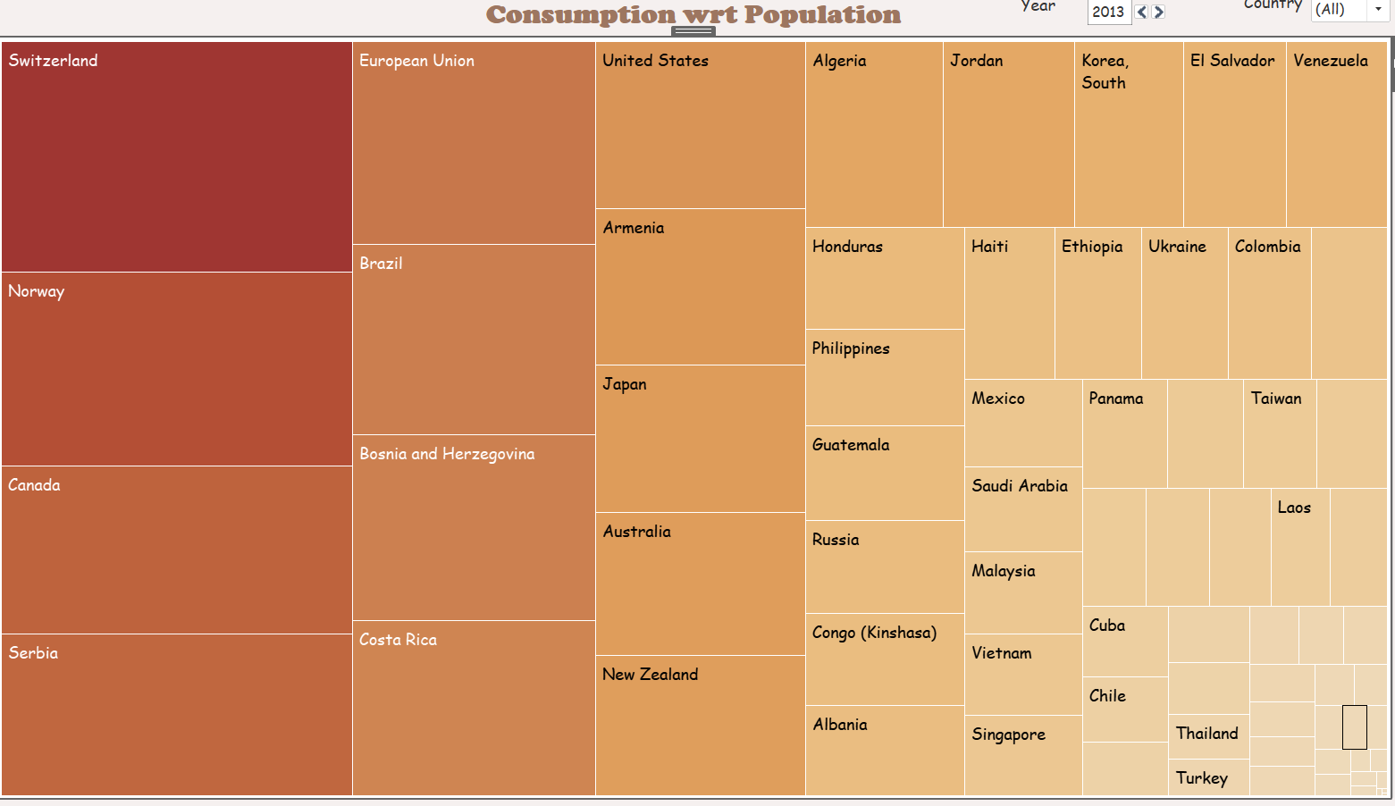

Key Findings

Chapter 1:
Comparing the changes in the years between 1990 to 2023, coffee production has surged by 71%, while domestic consumption has increased nearly sixfold. Imports have skyrocketed, growing by 400 times, and exports have risen by 87%.

Chapter 2:
Arabica consistently surpassed Robusta in production almost every year from 1990 to 2023. Brazil was the leading producer during this period. The spike in for EU is likely attributed to the aggregation of data from all EU countries after the introduction of the Euro currency in 2002.

Chapter 3:
Roast and ground coffee emerged as the most consumed type, presumably driven by increased purchases of coffee machines and changes in roasting practices, particularly focused on evolving blends. EU became the top importer after aggregated data collection began in 2002. Exports have generally mirrored production levels, with Brazil consistently ranking as the top exporter.

Chapter 4:
The size of coffee beans increases over the years across all countries, with little to no observed shrinkage. Larger bean correlate with the top consumption countries highlighted in Chapter 2.

Chapter 5:
Notably, Switzerland, Norway, and Canada exhibited growth in consumption per capita, suggesting potential opportunities for expansion.

Limitation and Further work
Limitations
- The dataset has data discrepancies from 1990 to 2002 for some countries.
- The dataset only provides aggregated data for the EU, lacking granularity at the individual country level.
- Coffee brands exhibit diverse pricing structures and brand images. Thus, to accurately assess profitability potential, we require additional data on each country's economy such as GDP or consumer price indexes.

Possible extensions
With extended time, incorporating additional metrics to help each individual C-suite make detailed decisions would significantly refine the recommendations for new coffee chain outlets. Here's how these factors could enhance the analysis:
- For COO: Land Costs

High land costs can significantly affect the initial investment required to open new outlets and influence decisions on whether to buy or lease properties. This data would allow for a more accurate estimation of startup costs in different regions.
- For CFO: Local Taxation

Incorporating local taxation information, including corporate tax rates, sales taxes, and any applicable tax incentives or exemptions for businesses, would provide a clearer picture of the financial viability of opening outlets in different jurisdictions.
- For CMO: Political pressures and cultural openness to international brands

Understanding political stability, regulations, and government policies toward foreign businesses would help in assessing risks associated with each market.

Acknowledgement
I extend our sincere gratitude and appreciation to Prof. Han Reichgelt, PhD for giving me the opportunity to explore Tableau using real data. This project has been a delightful journey, allowing me to apply and reinforce the Tableau knowledge i acquired in the classroom setting, bridging the gap between theory and practical application.

References
- US Coffee Market: statista
- Coffee distribution: kaggle
- Coffee consumption: kaggle
- Population data of each country over the span of 1990-2023: data.gov

